Name__________________________________________________________________________Date___________Hour______

Hooking Up! Genetics Problems
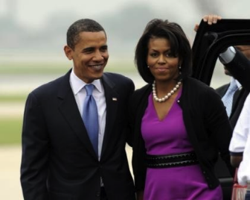
- President Obama and Mrs. Obama are looking to have another child. They are both heterozygous for rolling their tongues, which is a dominant trait (R). What are the possible genotypes for their next child? Phenotypes?
To solve this problem follow the steps below

Step 1: Write out the parent genotypes cross:
Step 2: Punnett square: Figure out the gametes. Put the parent gametes in
the proper locations & fill in the boxes.

Step 3: Interpret the data. Back to the Obama’s child…what are the percentages of each phenotype
and genotype?
Phenotypes: ____________________
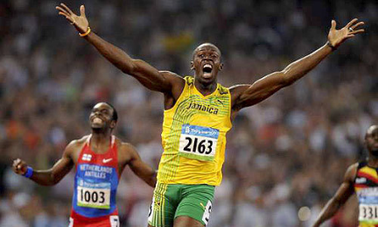
Genotypes: ___________________________
Use the following steps to answer the rest of the questions!

- Usain Bolt, the world’s fastest man, is heterozygous for unattached earlobes, which is a dominant trait (E). He marries a woman with attached earlobes. Using a Punnett square, determine the phenotypes and genotypes of their children.

  - Genotypes of the parents:

  - Punnett square:
% Genotypes of children:

% Phenotypes of children:



- Dimples are a dominant trait (D). Bill Gates does not have dimples, but his wife does. She is homozygous for having dimples.

  - Genotypes of the parents:

  - Punnett square:
% Genotypes of children:

% Phenotypes of children:

  - Will any of their children not have dimples?
- In Ogres, big noses (B) are dominant to small noses. Shrek is heterozygous for his big nose. Princess Fiona has a small nose. What will the phenotypes be for their children? What will the genotype be? Use a Punnet square.
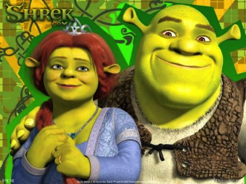
  - Genotypes of the parents:

  - Punnett square:
% Genotypes of children:

% Phenotypes of children:

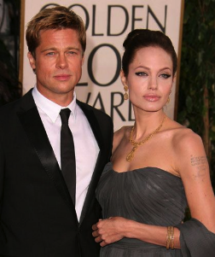
- Brad Pitt and Angelina Jolie take their new baby home from the hospital. Both of them have a second toe is longer than their first toe, which is a dominant trait (L). Brad is homozygous for his longer second toe, but Angelina is heterozygous. Their baby has a shorter second toe. Angelina is furious because she says that this is not her baby. Is she right? Use a Punnett square to explain your answer.

  - Genotypes of the parents:

  - Punnett square:
% Genotypes of children:

% Phenotypes of children:

  - Is Angelina right?

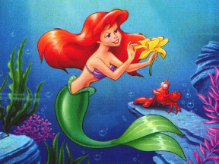
- In mermaids, green tails are a dominant trait (G). Ariel is heterozygous for a green tail. If she marries Francois, who has a blue tail, what is the phenotype of their children? The genotype? Use a Punnett square to explain your answer.

  - Genotypes of the parents:

  - Punnett square:
% Genotypes of children:

% Phenotypes of children:


- When Lebron James clasps his hands together, his left thumb is on top, which is a dominant trait (L). He is heterozygous for this trait and has a child with a woman who is also heterozygous. Is there a chance that their child will put their right thumb on top (recessive trait)? Use a Punnett square to explain your answer.

  - Genotypes of the parents:
% Genotypes of children:

% Phenotypes of children:

  - Punnett square:

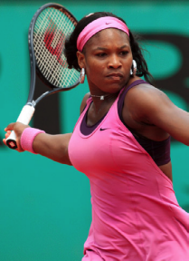
- Serena Williams does not have a cleft chin (Cleft chin (G) is dominant). She decides to marry a man who is homozygous for having a cleft chin.
  - Genotypes of the parents:

  - Punnett square:
% Genotypes of children:

% Phenotypes of children:

  - Will any of their children not have cleft chins?

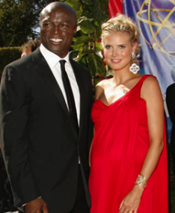
- Heidi Klum and Seal’s daughter has blue eyes, which is recessive to brown eyes (B). If Heidi has blue eyes and Seal has brown eyes, how can Leni have blue eyes? Write the genotypes and phenotypes for Heidi, Seal, and Leni. Use a Punnett square to show how Leni can have blue eyes.
  - Heidi’s genotype: _________ phenotype: ____________
Seal’s genotype: _________ phenotype: ____________
Leni’s genotype: _________ phenotype: _____________

  - Punnett square:
% Genotypes of children:

% Phenotypes of children:

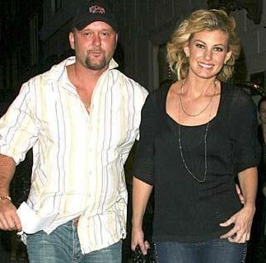
- Polydactyly is a dominant genetic condition where an individual has extra fingers or toes. Faith Hill was born with an extra finger on her left hand. She is heterozygous for this trait. Tim McGraw has a recessive genotype because he has only 5 fingers on each hand. What is the possibility that their next child will have 6 fingers?
  - Genotypes of the parents:

  - Punnett square:
% Genotypes of children:

% Phenotypes of children:

  - What is the possibility that their next child will have 6 fingers?

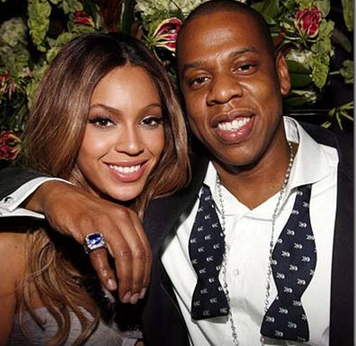
- Beyonce and Jay Z want Blue Ivy to have a sibling. However, Beyonce is worried because Jay Z has a unibrow (a dominant trait). She doesn’t want her children to have the same attached eyebrows. Beyonce is recessive for unattached eyebrows.

  - Genotypes of the parents:
  - Punnett square:
% Genotypes of children:

% Phenotypes of children:

  - What is the possibility that their child would have a unibrow?

- Michael Phelps’s pinky finger is bent towards his ring finger, which is a dominant trait (B). He is heterozygous. If he wants to increase his chances at having a child with a straight pinky finger, what genotype and phenotype should he look for in his mate? Use a Punnett square to explain your answer.

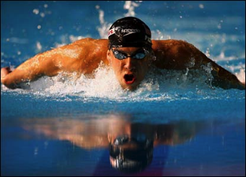
  - Michael Phelp’s genotype: _____________ Phenotype: _______________

  - Possible Punnett square:
  - What genotype and phenotype should he
look for in his mate?
Mate’s phenotype: _______________
Mate’s genotype: _______________
% Genotypes of children:

% Phenotypes of children:

