Name:_______________________________ Date:___________ Hour:_____
Building an Atom Lab
Prelab Questions:
1. What is an atomic nucleus?

2. What two atomic particles compose the nucleus of an atom?

3. How do you figure out the number of protons and neutrons?

4. Where are electrons located in an atom?

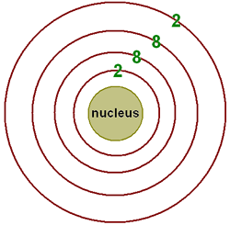
5. Below is a diagram of electron shells. In the boxes, fill in the maximum number of electrons for each of the 1st 4 shells.

6. How do you fill electrons in their shells?

Creating you atom:
Choose one of the following elements: Magnesium, Aluminum, Silicon, Phosphorus, Sulfur, Chlorine, Argon, Potassium, or Caclium.

My chosen element:____________________________

Atomic Mass for my element:___________________________ Atomic Number for my element:________________

Number of Protons in my element:
Number of Electrons in my element:
Number of Neutrons in my element:

How many electron shells will my element have?
On a piece of construction paper, write your name in the top right corner and the element name underneath it.

Create a legend and glue a bean for each of your atomic particles.

Create the appropriate atomic structure for your chosen atom. Make sure that your legend and your picture match!

Bonus: Draw the atoms of the isotopes listed below:

Hydrogen- 3 Argon-41

Boron-11 Lithium- 8

Oxygen-14 Helium- 3

****STAPLE THIS PAGE TO YOUR CONSTRUCTION PAPER!

