Name_______________________________________________________________Date__________Hour____

Carbon Cycle & Global Warming: It’s Gettin’ Hot in Here!

Part I. Cycles
In ecosystems, energy flows from one organism to the next. It is sometimes depicted as a cycle, where energy moves from producers to consumers, and then can be partially replenished by decomposers.
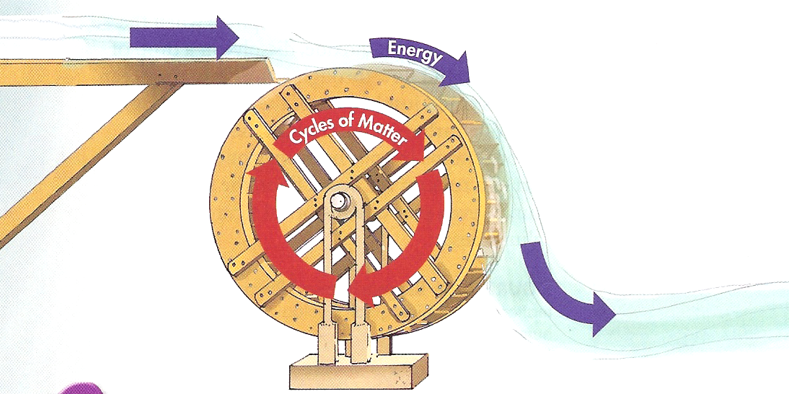
Look at the diagram to the right to answer the following questions.

- What is cycling in this diagram?

- What is the difference between matter and energy in this diagram?

- Because energy flows in a one-way direction and does not cycle, how is it replaced?

Now that you know that matter cycles through ecosystems, we are going to examine how a certain type of matter cycles: carbon! Look at the picture of the Carbon Cycle below and answer the questions that follow.

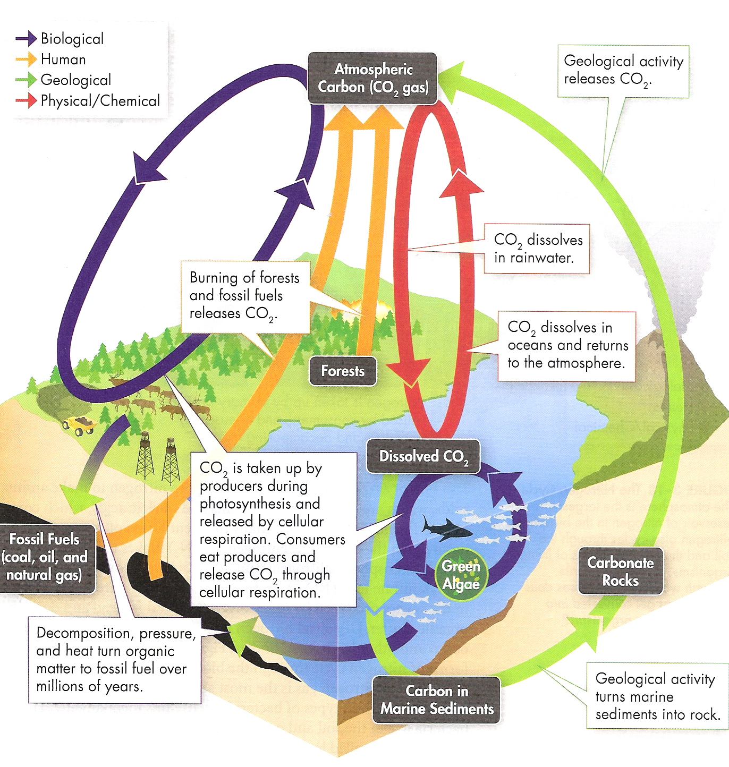
- The diagram shows that CO₂ in the atmosphere is taken in by plants during photosynthesis. How do plants use CO₂? What form do you think CO₂ transformed into?

- What are the 4 biomolecules that make up living things? Do these biomolecules contain carbon?

- What role does decomposition play in this cycle?

- What do you think ‘detritus’ is?

- Fossil fuels are formed by buried dead organisms that have been under a lot of pressure for a very long time. They are named so because they are basically fossilized carbon. What role does the burning of wood and fossil fuels play in this cycle?

- Redraw the carbon cycle in your own way (do NOT copy the picture!!)

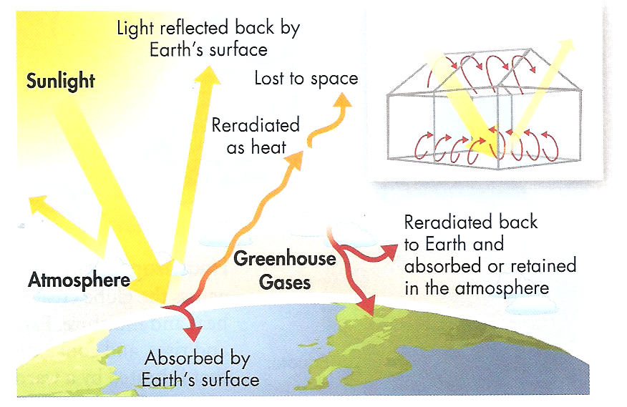
Part II. Global Warming
- What gases are present in the atmosphere?

- What does a greenhouse do?

- Looking at the diagram, what is the greenhouse effect?

- How does the greenhouse effect cause global warming?

- What two human activities are increasing atmospheric CO₂? How does this affect global warming?

- How does deforestation affect atmospheric CO₂?

- What would happen if Earth did not have the greenhouse effect?

