Name _____________________ Cell Cycle Manipulation Lab Biology A
Hour ______ Date ________

Cycle Lab

Procedure:

Interphase is the busiest time of the cell cycle. The cell spends most of its life in interphase. During this phase the cell grows and prepares to replicate. In preparation for mitosis long strands containing DNA called chromatin are present inside the nucleus.. Using this knowledge, draw a cell in interphase, then find the picture at the end of the lab and paste it into the box below.

Draw Cell Here Paste Picture Here

Prophase is the first official phase of the cell division cycle known as mitosis. During this phase the chromatin coils up to make chromatids. Remember, when two sister chromatids come together and link up, they are now known as a chromosome. Prophase is the first time chromosomes appear in the cell. During this phase, the nucleus also dissolves away to allow the chromosomes to move. Centrioles move to opposite poles of the cell during prophase. Draw your cell representing all the parts of prophase below, then find the picture of a cell in prophase at the end of your lab and paste it below.

Draw Here Paste Picture Here

The second official phase of mitosis is called metaphase. During metaphase, the previously formed chromosomes line up along the middle of the cell with the help of spindle fibers. The spindle fibers extend from the centriole and connect to one side of each chromosome. Draw your cell representing all the parts of metaphase below, then find the picture of a cell in metaphase at the end of your lab and paste it below.

Draw Cell Here Paste Picture Here

Anaphase is the next step of mitosis. During this step, the centromeres that hold together the sister chromatids break apart. This allows the spindle fibers to shorten and pull apart the chromosomes. Draw your cell representing all the parts of anaphase below, then find the picture of a cell in anaphase at the end of your lab and paste it below.

Draw Cell Here Paste Picture Here

The fourth and final phase of mitosis is telophase. The chromatids continue to pull further apart. Once the chromatids reach opposite sides of the cell a cleavage furrow forms. Each chromatid is now known as a chromosome. As animal cells separate in telophase, a cleavage furrows forms. The rigid cell wall in plants means that no cleavage furrow can form and is replaced with a cell plate.
Draw your cell representing all the parts of telophase below, then find the picture of a cell in metaphase at the end of your lab and paste it below.

Draw Cell With Cleavage Furrow Draw newly formed Daughter Cells Paste Picture Here

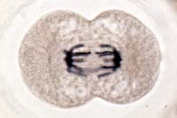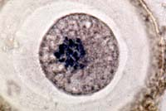 Now that you have seen an example of the steps of the cell cycle, cut out the following microscope pictures that illustrate cell division and paste them in there correct phase.

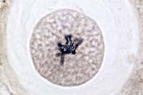

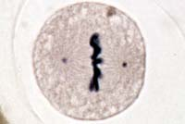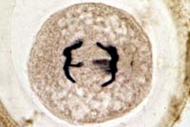

Answer the following questions based on today’s lab.

- What is the correct order of mitosis?

- What did the orange circles represent?

- While tending to his famous rose garden Mrs. Wang decided to use his microscopic vision to observe the rose stem cells undergoing telophase. Mrs. Wang thought he saw a cleavage furrow form, but he was mistaken. Why was he wrong? What else would he observe during telophase?

- On a recent visit to Princeton Plainsboro hospital an ailing Mr. Cosnowski was told he was getting sick because all of his cells lacked spindle fibers. If you were Mr. Cosnowski’s doctor, Dr. House, how would you explain what spindle fibers do, and why they are important?

