ssssssssssssName:___________________________________ Date:______________ Hour:______
College Readiness Standards Breakdown
1. What should you do to the question you are trying to answer?

2. Underline the important words in test question 2, and circle what they correspond to on the table. Put a question mark next to the column that you are looking for.

3. What is the correct answer for test question number 2? How did you figure it out?

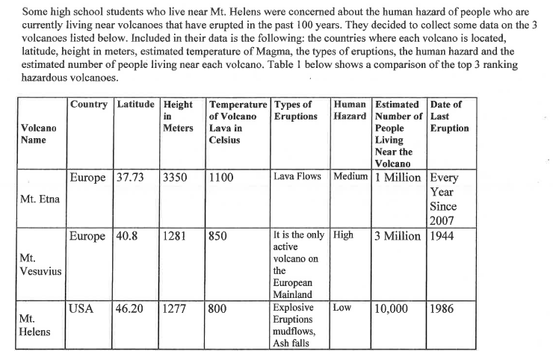
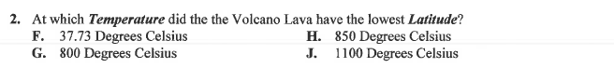
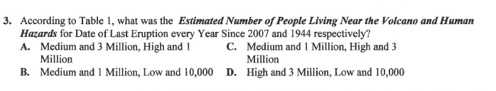

4. Underline the important words in question 3, and circle what they correspond to on the table. Put a question mark next to the columns that you are looking for.

5. What does the word RESPECTIVELY mean in this question?

6. What is the answer to question 3 on the exam? Explain in words how you figured it out.

7. Based on what you have practiced so far, what has caused you to answer questions incorrectly?

8. What are the steps you should take before you even answer the questions?

9. What marks should the test grader see on your charts and questions that indicate that you are carefully reading?

10. On the table below, please draw arrows on each column indicating if the column is increasing or decreasing. If it is doing neither, then shade in the title cell of the column.

