Name:___________________________________ Date:______________ Hour:______
College Readiness Standards Breakdown
1. Underline the important words in question 4.

2. What makes question 4 different from the other questions so far?

3. Question 4 is the most challenging. To figure it out, test out each of the answer choices. If the answer is not correct, CROSS IT OUT!

4. What is the answer to test question 4? How did you determine the answer?

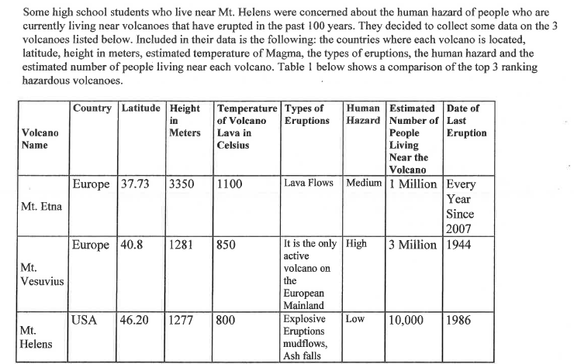

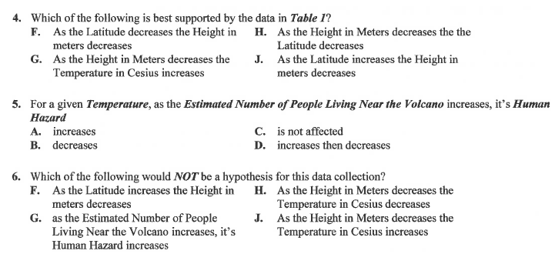

6. Underline the important words in question 5.

7, Compare each of the three cells in each column. What is the overall trend between Estimated number of people living near the volcano and Human Hazard?

8. Go through the answer choices for number 5 and cross out the incorrect answers.

9. What is the correct answer for test question 5? How did you reach this conclusion?

10. What is a hypothesis?

11. What makes a hypothesis different from a problem or question?

12. Underline the important words in test question 6.

13. What makes test question 4 different from the other questions so far?

14. Question 4 is the most challenging. To figure it out, test out each of the answer choices. If the answer is not correct, CROSS IT OUT!

15. What is the answer to test question 4? How did you determine the answer?

