Name:____________________________________ Date:__________ Hour:____
Notes: Elements and Atoms
The Elements- Objectives: To learn about the relative abundances of the elements, and to learn the names of some elements.
- Vocabulary:
- Element: A pure __________________ __________________ consisting of 1 type of atom and its own ____________________________________.
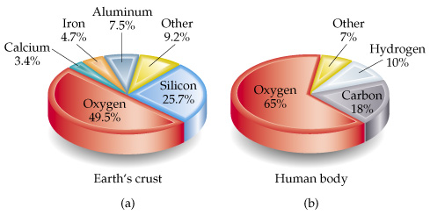
- About ________ elements are known
- __________ exist in nature
- The term element can mean:
- A __________________ atom
- A __________________ form of an element
- A sample large enough to weigh on a balance (__________________ form)

Symbols for the Elements- Objective: To learn the symbols of some elements
- Vocabulary:
- _______________________ : a set of abbreviations for the chemical elements
- How Symbols Work: Usually the first ____________________________________ of the element’s name

- Examples:
Element | Symbol
Carbon | __________________
Fluorine | __________________
Oxygen | __________________
Neon | __________________
Silicon | __________________

- Exception Number One: sometimes, the letters are not the first two
Element | Symbol
Zinc | __________________
Chlorine | __________________
Platinum | __________________

- Exception Number Two: some symbols are based on the original Latin or Greek names:
Current Name | Original Name | Symbol
__________________ | Aurum | Au
__________________ | Plumbum | Pb
__________________ | Natrium | Na
__________________ | Ferrum | Fe
__________________ | Argentum | Ag
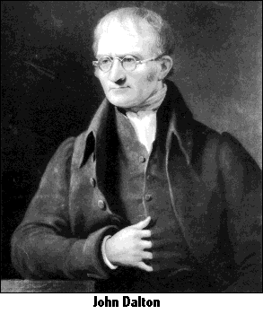
Dalton’s Atomic Theory- Objectives: to understand the law of constant composition
Vocabulary:
- The law of composition:
- A given compound always has the same composition, regardless where it comes from

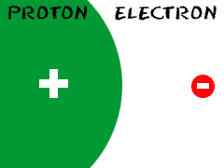
Structure of the Atom- Objectives: to learn about the internal parts of an atom, and to understand Rutherford’s experiment to characterize the atom’s structure
- Vocabulary:
Particle: ______________________________________________
Relative Mass: The mass of a particle when compared to an _________________
Particle | Actual Mass | Relative Mass | Relative Charge
______________ | 9.1 x 10⁻³¹ kg | 1 | -1
______________ | 1.673 x 10⁻²⁷ kg | 1836 | + 1
______________ | 1.674 x 10⁻²⁷ | 1839 | None
Relative Charge: The charge of a particle when compared to an electron
1. What does relative mean?

2. Which particle is the largest?

3. Which two particles are the closest in size?

4. Which particle is the smallest? How much smaller?

Element | Protons | Neutrons | Electrons
Zn
Mg
Sr
Co
Ne
As
Particle Numbers and the Periodic Table- Objective: To understand how to determine the numbers of protons, neutrons, and electrons using the periodic table
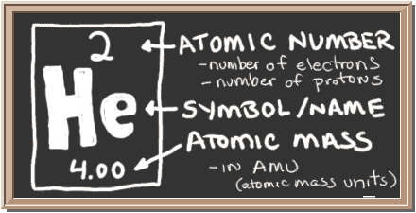
- Atomic Number: The number of protons (and electrons). ___________________ to each element
- Atomic Mass: the weight of each atom.
- ____________________- _____________________= # of ___________________

5. What is the atomic number of lithium? 9. Complete the table:

6. How many protons in lithium?

7. How many electrons in lithium?

8. How many neutrons in lithium?

Name:__________________________________ Date:__________ Hour:_______
Notes: Atomic Structure- Part 2
Before we begin Atomic Appearance:
1. What does PEN stand for? 2. What are the charges of PEN particles?

3. Find PEN for the following elements:
Rubidium (Rb) Nickel (Ni) Xenon (Xe)

Part One: Atomic Notation- Objectives: To understand how to create and read atomic notation:
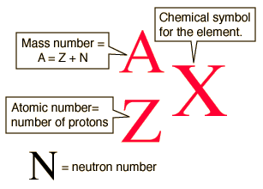
Atomic Notation
- X = ___________________ of the elements
- A = ___________________
- Z = ___________________
Practice
- What is the atomic notation for Sodium?

Practice
- What is the atomic notation for Sodium?

Practice
- Write the atomic notation for Copper (Cu)

Time for: Atomic Notation Practice!!

Part Two: What is an Isotope? Objective: to define and determine isotopes
- Isotope: a ___________________of an atom that has a different number of ___________________
- There is no such thing as a different number of ___________________! If you change the number of protons, you change the ___________________ you are working with!!
Carbon Isotopes
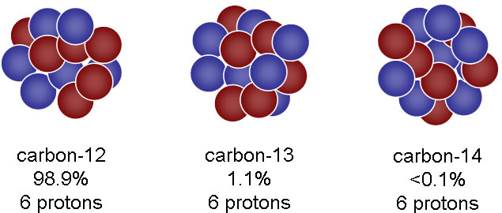
____________ ___________ ___________
- Atomic mass is an ___________________ of all of the different isotopes of the atom. For example, find carbon’s atomic mass: ___________________
- Carbon 12: __________ neutrons
- Carbon 13: __________ neutrons
- Carbon 14: __________ neutrons
How to Calculate Isotopes
- Use the atomic notation to determine the number of neutrons in the isotope:
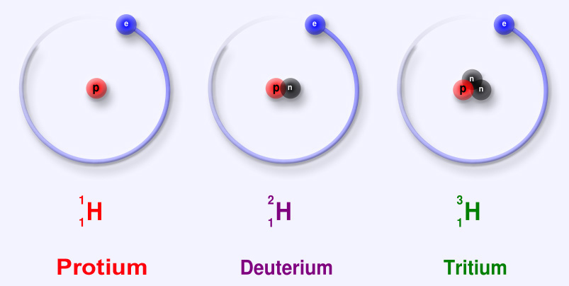

Neutrons: ___ ___ ___

Determine the Atomic Notation for Carbon 14

Time for: Isotope Practice!

Part 3: Drawing Atoms
- Drawing The Nucleus (1st way):
- Draw the correct number of circles for __________ and put the __________ symbol in the circle
- Draw the correct number of circles for __________ and put an __________ in the center of the circle
- Drawing Atoms- the BOHR MODEL
- Draw a circle for the nucleus
- Write the ________________________________________ in the middle:
- Example:
12P
13N
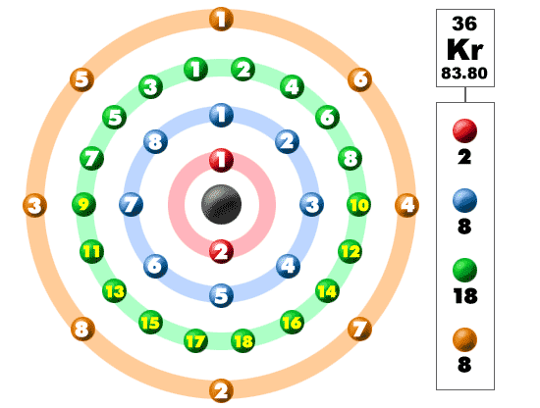
- Electrons! Electrons orbit the nucleus in specific levels called __________. Each shell can hold a different number of __________
- 1st shell: ___
- 2nd shell: ___
- 3rd shell: ___
- 4th shell: ___
- 5th shell: ___
- 6th shell: ___
- Fill the shells from the inside to the outside!
Lets try! Draw:
a Helium atom a Lithium atom a Carbon atom

