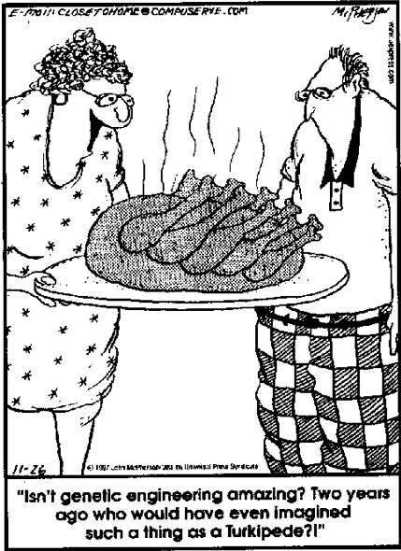
Name_____________________________________________Date________Hour____
GENETIC ENGINEERING
Would you want to clone your pet? Would you change your child's eye color? Do you care if your strawberry contains a gene for fish? Genetic engineering is changing the way we live. This is a fascinating area that deserves our attention. Decisions and choices we make in our lifetime will affect how and why genetic engineering is used.
- So what do you think Genetic engineering means?

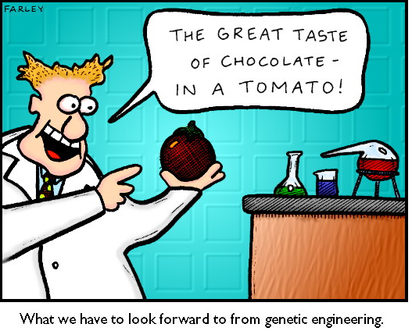
Genetic engineering is a laboratory technique used by scientists to change the DNA of living organisms.
- BUT WAIT…. if we change our DNA what will also change (remember the central dogma of biology)?

DNA is the blueprint for the individuality of an organism. The organism relies upon the information stored in its DNA for the management of every biochemical process. The life, growth and unique features of the organism depend on its DNA. The segments of DNA which have been associated with specific features or functions of an organism are called genes which in turn create proteins that make us who we are.
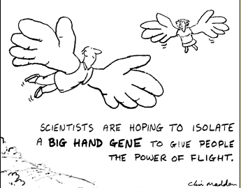
Molecular biologists have discovered many enzymes which change the structure of DNA in living organisms. Some of these enzymes can cut and join strands of DNA. Using such enzymes, scientists learned to cut specific genes from DNA and to build customized DNA using these genes. They also learned about vectors, strands of DNA such as viruses, which can infect a cell and insert themselves into its DNA.
With this knowledge, scientists started to build vectors which incorporated genes of their choosing and used the new vectors to insert these genes into the DNA of living organisms. Genetic engineers believe they can improve the foods we eat by doing this. For example, tomatoes are sensitive to frost. This shortens their growing season. Fish, on the other hand, survive in very cold water. Scientists identified a particular gene which enables a flounder to resist cold and used the technology of genetic engineering to insert this 'anti-freeze' gene into a tomato. This makes it possible to extend the growing season of the tomato.

- What other things do you think have been possible using genetic engineering?

Today you will be reading articles about different aspects of our lives touched by genetic engineering.
Directions:
- Read the attached article, highlight, & underline important facts (FOCUS: what can genetic engineering do)
- Answer the questions that follow about your reading
- Create a poster that explains your article. Be sure to include pictures and the required information!

Transgenic Crops Cut Toxins, Boost Ecosystem
By Andrew Curry

Environmentalists who are skeptical about genetically modified crops should think again, judging from a study published last June. Researchers reported in the journal Nature that transgenic cotton bred to resist pests increases biodiversity by reducing the amount of insecticide sprayed on fields.

The scientists tracked cotton plots in China from 1990 to 2010 as farmers switched from conventional seeds, which require insecticide spraying as many as 15 times a year, to a transgenic variety that produces a protein toxic to crop-ravaging insects like the cotton bollworm. Today so-called Bt cotton is planted on nearly 60 million acres in China, making up more than 95 percent of the country's total crop. The result: "With the Bt cotton, chemical use decreased 60 percent," says Kongming Wu, an entomologist with the Chinese Academy of Agricultural Sciences.
Wu and his colleagues determined that reduced spraying resulted in less collateral damage to other insect species, particularly beneficial predators like spiders, ladybugs, and lacewings. That heartier population of predators in turn feasted on harmful pests that are unaffected by insecticides, such as the cotton aphid. Such natural pest control occurred not only in the plots of Bt cotton but also in neighboring fields of conventional corn and soy.

The findings also provide a cautionary lesson, though. Chinese farms are small on average, Wu notes, and farmers typically plant conventional crops next to their Bt cotton. "That way, insects can use corn as a natural refuge so they don’t evolve resistance to Bt," he says. But the commercial farms that predominate in the United States tend to plant large plots of a single crop. Without accessible refuges, Wu warns, that practice could lead to the emergence of Bt-resistant super-pests.

1. What is the main idea of this article?

2. Describe the genetic engineering that is taking place

3. What are some benefits of this type of genetic engineering?

4. Describe at least one drawback of this type of genetic engineering:

1. . What is the main idea of this article?

2. Describe the genetic engineering that is taking place

3. What are some benefits of this type of genetic engineering?

4. Describe at least one drawback of this type of genetic engineering:

Genetically Engineered Immune Cells Found to Rapidly Clear Leukemia Tumors
The new therapy for acute lymphoblastic leukemia, a swift-growing cancer that tends to kill more than 60 percent of those afflicted, involves extracting T cells and modifying them to home in on and destroy B cells in healthy and cancerous tissue
By Heidi Ledford and Nature magazine
Genetically engineered immune cells can drive an aggressive type of leukemia into retreat, a small clinical trial suggests.
The results of the trial — done in five patients with acute lymphoblastic leukemia — are published in Science Translational Medicine and represent the latest success for a 'fringe' therapy in which a type of immune cell called T cells are extracted from a patient, genetically modified, and then reinfused back. In this case, the T cells were engineered to express a receptor for a protein on other immune cells, known as B cells, found in both healthy and cancerous tissue.
When reintroduced into the patients, the tricked T cells quickly homed in on their targets. “All of our patients very rapidly cleared the tumor,” says Michel Sadelain, a researcher at the Memorial Sloan-Kettering Cancer Center in New York and an author of the study. The treatment “worked much faster than we thought”.
The technique has already shown promise against chronic leukemia, but there were doubts about whether it could take on the faster-growing acute lymphoblastic leukemia, a tenacious disease that kills more than 60% of those afflicted.
Carl June, an immunologist at the University of Pennsylvania in Philadelphia and a pioneer in engineering T cells to fight cancer, says that he is surprised that the method worked so well against such a swift-growing cancer. The next step, he says, is to move the technique out of the ‘boutique’ academic cancer centers that developed it and into multicenter clinical trials.
“What needs to be done is to convince oncologists and cancer biologists that this new kind of immunotherapy can work,” he says.

Extra hope
Oncologist Renier Brentjens, also at Memorial Sloan-Kettering Cancer Center, remembers the day that he had to tell one of the patients in the trial that the weeks of high-dose chemotherapy the 58-year-old man had endured had not worked after all. “It was painful to have that conversation,” says Brentjens. “He tells me now it was the worst news he has ever heard in his life.”
Another month in the hospital on intensive chemotherapy drugs did nothing to help. By the time the man started the trial, 70% of his bone marrow was tumor.
Brentjens, Sadelain and their colleagues then extracted T cells from the patient and engineered them to express a ‘chimeric antigen receptor’, or CAR, that would target cells expressing a protein called CD19. Because CD19 is found on both healthy and cancerous B cells, the engineered T cells were unable to discriminate between the two. However, patients can live without B cells.
By two weeks after the procedure, the patient was showing signs of improvement. The treatment had driven his cancer into remission — as it did for the other four patients in the trial — so he became eligible for a bone-marrow transplant. A hundred days later, he is doing well, says Brentjens. Four of the five patients were well enough to receive transplants; the remaining patient relapsed and was ineligible.
Pharmaceutical firms have tended to be wary of the CAR technique because it is technically challenging, must be personalized to the patient and faces an untested path to regulatory approval, says Steven Rosenberg, head of the tumor immunology section at the National Cancer Institute in Bethesda, Maryland.
But this seems to be changing. Rosenberg points to a collaboration formed in August last year between June's group and the drug giant Novartis, as well as the launch of several small CAR-focused biotechnology firms. And Sadelein says that he is an investigator on a trial with the Dana-Farber Cancer Institute in Boston, Massachusetts, to test whether the technique can be exported to other treatment centers, among other outcomes.
Brentjens, meanwhile, is happy to have his patients in fighting spirits again. “You see these people at their lowest low emotionally as well as physically,” he says. “And now you can tell they’re in better shape because they’re making fun of your tie again.”

On a separate sheet of paper, please answer the following questions:
1. What is the main idea of the article
2. Summarize the article in 4 to 6 sentences
3. What are some benefits of this type of genetic engineering?
4. What are some drawbacks of this type of genetic engineering?

