Name_____________________________________________________________Date__________Hour______
Membrane Transport

- The Cell Membrane (aka: the PLASMA membrane)
- What does it do?
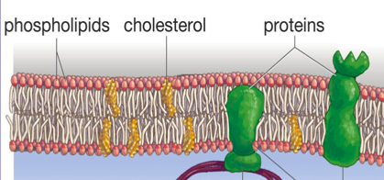
- ____________________________________
- Maintains ______________________: controls what ____________ & ___________the cell
  - Hormones, food, waste, etc
- What is it made of?
- _______________________________
- _______________________________

- Types of Transport across the Cell Membrane
    - ______________________Transport
Movement of substances across a cell membrane:
- From ____________ to __________ amounts (concentrations)
- Uses __________ energy
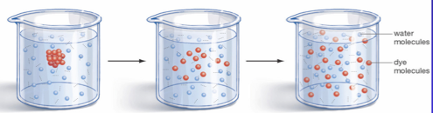
      - DIFFUSION
- Requires _______ energy
- Gasses and small molecules move from an area of ____________ to __________ amounts (concentrations)

CHECK FOR UNDERSTANDING:
Diffusion of oxygen through the cell membrane. How will the oxygen move?

a. b. OUTSIDE THE CELL

c.
INSIDE THE CELL

      - OSMOSIS
- Movement of ____________ across a cell membrane
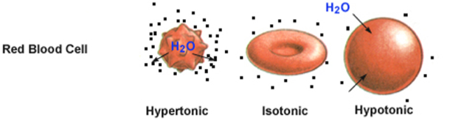
- Moves from ____________ water amount (low solute) to a __________ water amount (high solute)

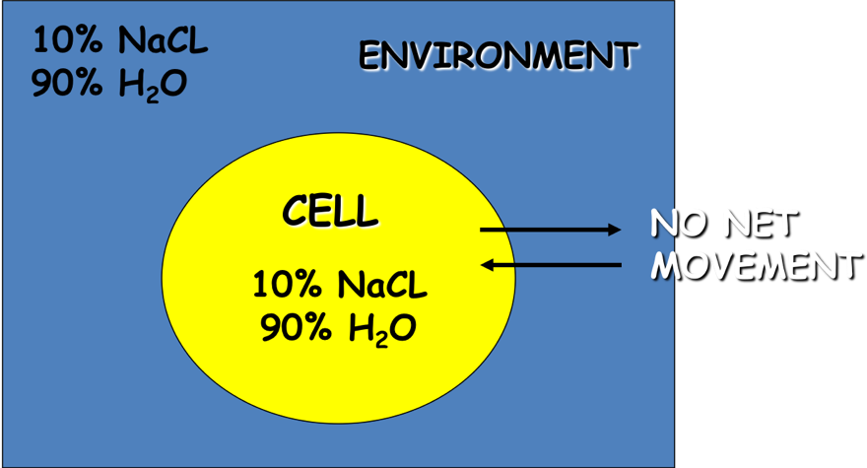
        - ISOTONIC SOLUTION
- Amount of water is ____________ inside and outside of cell
- The cell will______________________________

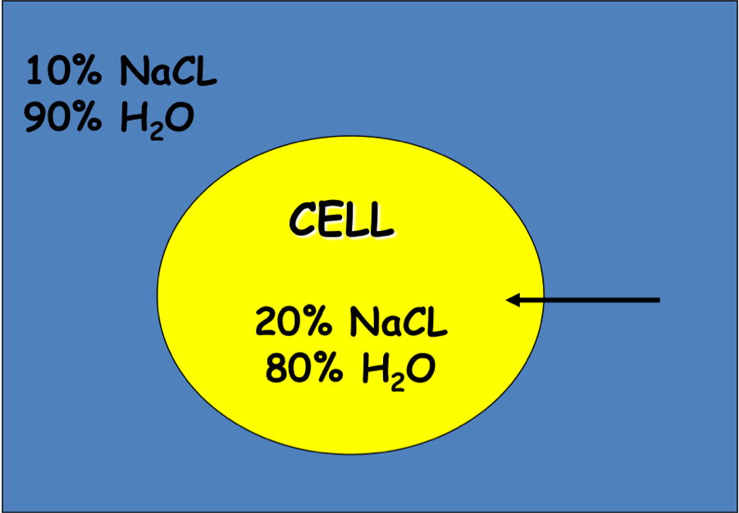
  - HYPOTONIC SOLUTION
- More water ______________ the cell
- More solute ______________ the cell
- The cell will ______________________________________
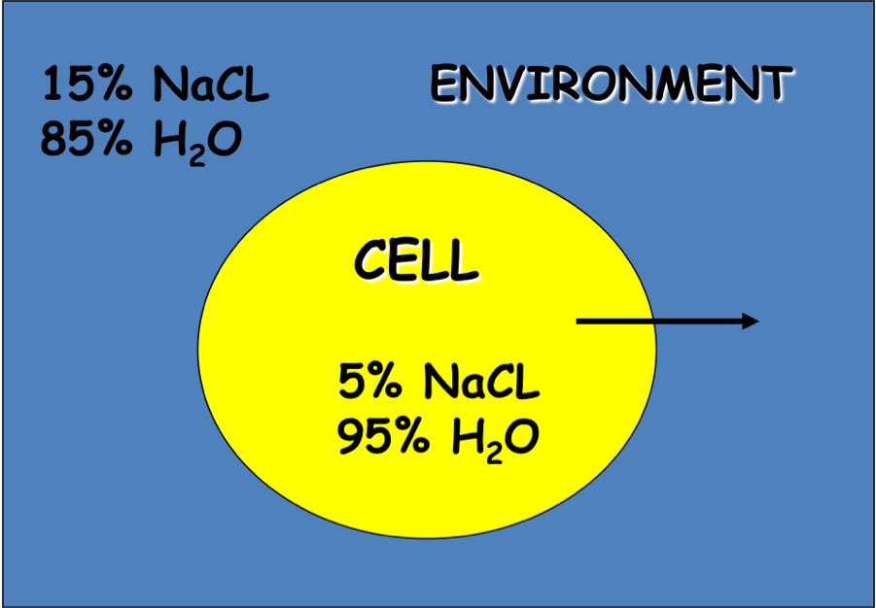
  - HYPERTONIC SOLUTION
- More water ______________ the cell
- More solute ______________ the cell
- The cell will ____________________________

CHECK FOR UNDERSTANDING
CELL A
= SOLUTE
W = WATER

W W W What type of solution is Cell A in? ____________________________
W W What will happen to cell A? ____________________________
W W W

3. FACILITATED DIFFUSION
- ________________ require energy
- Uses _____________________________________ to move from an area of ____________ to __________ amounts (concentrations)
  - Examples: Glucose or amino acids moving from blood into a cell

B. ________________ TRANSPORT
- Requires ________________ or ATP
- Moves materials from ____________ to __________ amounts (concentrations)

B.
A.
CHECK FOR UNDERSTANDING
Which carrier protein would be used in this situation to get the solute across the membrane? __________________________
What type of transport is this? __________________________

- BULK MOVEMENT
- Movement of _____________________________________ molecules
- Requires _____________________
      - EXOCYTOSIS- __________________________________________________________
      - ENDOCYTOSIS- _________________________________________________________

