Name:___________________ Date:___________ Hour:_____
Phase Changes Review
Fill in the blank words (you will not use every word):
Temperature Solidification/Freezing Melting Evaporation Condensation
Sublimation Gas Deposition Solid Slowly Liquid Increase Decrease Rapidly

In order for a substance to move between the states of matter; for example, to turn from a solid into a liquid, which is called _______________________, or from a gas to a liquid ________________ (vaporization), energy must be gained or lost. The heat of fusion of a substance is the amount of energy that must be put into the substance for it to melt. This energy causes the molecules to move ________________. Another way to commonly explain the movement of molecules is kinetic energy. Molecules speed up because molecular kinetic energy _____________ and molecules slow down because molecular kinetic energy ______________. Changes in the states of matter are often shown on phase diagrams. Phase diagrams can be seen with heat on the x-axis and temperature on the Y-axis OR temperature on the x-axis and pressure on the y-axis

The first type of phase change graph you might see is called a heating curve. This is a graph of the change in temperature of a substance as energy is added in the form of heat. The pressure of the system is assumed to be held constant, at normal pressure (1 atm). As you can see from the graph below, at normal pressure water freezes at 0ºC and boils at 100ºC.
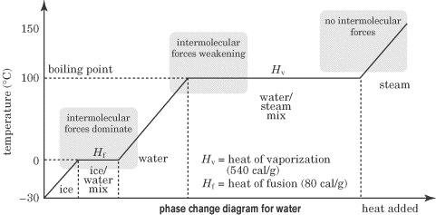

The plateaus on this diagram represent the points where water is being converted from one phase to another; at these stages the _____________ remains constant since all the heat energy added is being used to break the attractions between the water molecules.

1. Why does temperature remain constant as water changes phases? Circle the 2 places on the graph where this occurs.

2. Define “Molecular Kinetic Energy” in your own words.

4. You walked into the kitchen and found a pot heating on the stove where the water was beginning to boil, draw a picture of what the water molecules would look like in the pot and above the pot, and explain what is happening.

3. You walked into the kitchen and found a pot heating on the stove where the ice was beginning to melt, draw a picture of what the water molecules would look like in the pot and above the pot, and explain what is happening.

The second type of phase diagrams is a graph of pressure versus temperature. The phase diagram below is for water. Each of the lines on the graph represents an equilibrium position, at which the substance is present in two states at once. For example, anywhere along the line that separates ice and water, melting and freezing are occurring simultaneously.
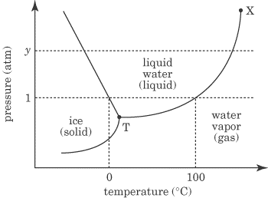
The intersection of all three lines is known as the triple point (represented by a dot and a T on the figure). At this point, all three phases of matter are in equilibrium with each other. Point X represents the critical point, and at the critical point and beyond, the substance is forever in the vapor phase.

This diagram allows us to explain strange phenomena, such as why water boils at a lower temperature at higher altitudes. For example, if you boil water at the top of a mountain, then the water molecules only need to be at about 80 degrees Celsius for the water to boil.
At higher altitudes, the air pressure is lower, and this means that water can reach the boiling point at a lower temperature.
Interestingly enough, water would boil at room temperature if the pressure was low enough. This phenomenon can actually occur on different planets in the galaxy!

Example
What happens to water when the pressure remains constant at 1 atm but the temperature changes from -10ºC to 75ºC?

Explanation
Looking at the phase change diagram for water and following the dashed line at 1 atm, you can see that water would begin as a solid (ice) and melt at 0ºC. All of the water would be in liquid form by the time the temperature reached 75ºC.

5. What are the similarities between the two graphs on this worksheet? What are the differences?
Similarities:

Differences:

6. Explain what would happen to the water if the temperature remained constant at 50ºC but the pressure increased from 0.5atm to 1.5 atm? Draw a picture of the molecules at each pressure in the boxes below:

0.5 atm

1.5 atm

7. Explain what happens to water if the pressure remains constant at 2.0atm and the temperature increases from -100ºC to 50ºC? Draw a picture of the molecules at each temperature in the boxes below.

-100ºC

50ºC

