Name:_____________________________ Date:________________ Hour:_________
Answer questions 1 through 3 for the bar graph below:
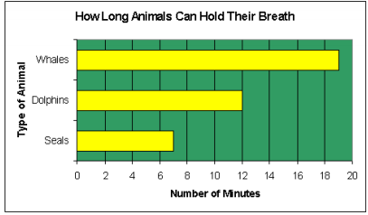
1. What is the independent variable? How did you know?

2, What is the dependent variable? How did you know?

3. How much longer can a dolphin hold its breath than a seal?

Answer questions 4 to 8 for the bar graph below:
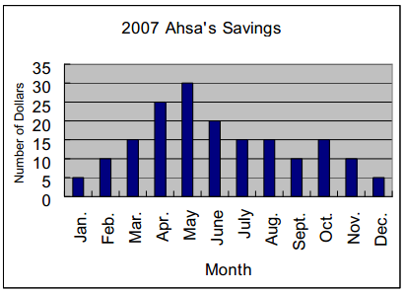
4. What is the independent variable in this experiment? How did you know?

5. What is the dependent variable in this experiment? How did you know?

6. How much did Asha save in March?

7. Did Asha save more in January – April or September – December? How did you determine the answer?

8. What months did Ahsa save the least?
a. January and February
b. January and December
c. March and April
d. March and October
Gases in Our Atmosphere
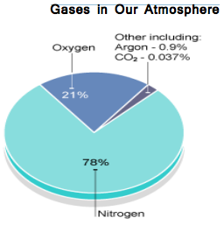
14. Which two gases make up most of our atmosphere?

15. What total percentage do those two gases make up? (Show work)

16. Which gases make up less than 1% of our atmosphere?

17. What is the difference in percentage between nitrogen and oxygen? (Show work)

18. What do all the percentages add up to? (Show work)

US Energy Consumption
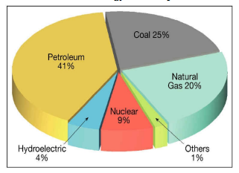
9. What are the top two categories for energy consumption?

10. What total percentage does hydroelectric and nuclear energy make up? (Show work)

11. What is the difference in U.S. consumption between coal and natural gas? (Show work)

12. What is the total percentage of all sectors in this pie graph? (Show work)

13. What is the smallest category in this graph? What is something that could fit into this category

