Name________________________________________Date______Hour_____

1. _________________________
2. _________________________
3. _________________________
4. _________________________
5. _________________________
6. _________________________
7. _________________________
8. _________________________
9. _________________________
10. _________________________
11. _________________________

RESPIRATION REVIEW

Fill in the diagram below

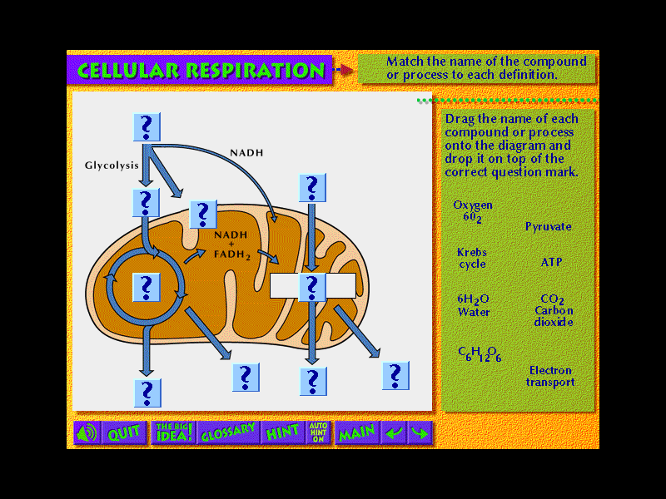

1

2.



3.

5

2

1.

3

4

6

7

4.

11

10

9

8

12. Where does each step of respiration occur?

13. What are the 3 steps of respiration?

What is needed for each step?

What is produced at each step?

14. What is the difference between aerobic and anaerobic respiration?

15. Explain both types of fermentation. Give an example of when each type is used.

16. Write the complete chemical formula for CELLULAR RESPIRATION (Use the diagram above to help you!).

17. How are photosynthesis and cellular respiration related?

18. Muscle cells can carry out either aerobic respiration or lactic acid fermentation. Why do they usually rely on aerobic respiration rather than fermentation?

19. Explain how the by-products of cellular respiration used by yeast makes them useful in the process of making bread.

20. A plant’s root cells do not contain chloroplast, so they cannot carry out photosynthesis. Explain how root cells get the energy they need to live.

CONCENTRATION OF CO2

MEASUREMENT OF CO2 PRODUCTION IN PLANTS

Flask A

Flask B

Flask C

**Use the graph to answer question 18.**

21. In which flask is only cellular respiration

taking place? Only photosynthesis? Both?

How do you know?

TIME

22. Would a baseball player running to first base and a cross-country skier use the same or different pathways to release energy? Explain answer.

23. Draw the diagram for cellular respiration on a separate sheet of paper 5 times and label it.

24. Write the balanced chemical equation for cellular respiration on a separate sheet of paper 5 times.

**Identification**. On the lines provided, identify which phrase describes the following processes:

Cellular respiration glycolysis lactic acid fermentation alcoholic fermentation

_________________________ 25. important in baking bread

_________________________ 26. produces 2 ATP molecules and pyruvate

_________________________ 27. requires oxygen and glucose

_________________________ 28. builds up in muscles after a few minutes of activity

_________________________ 29. the reason why runners breathe heavily after a race

**Answer the following questions by writing the letter or letters of the correct choice(s) on the lines provided**.

Choices: a. glycolysis b. Kreb’s cycle c. electron transport d. lactic acid fermentation e. alcoholic fermentation

______________ 30. Which processes produce lactic acid?

______________ 31. Which processes produce pyruvate?

______________ 32. Which processes occur in the mitochondria?

______________ 33. Which processes produce carbon dioxide?

______________ 34. Which processes require glucose?

______________ 35. Which processes produce ATP?

______________ 36. Which process produces the most ATP?

______________ 37. Which process produces ethanol?

______________ 38. Which processes require pyruvate?

Compare fermentation and cellular respiration by filling in the missing information in the compare/contrast table below. I

|  |  |  |
| --- | --- | --- |
|  | **Fermentation** | **Cellular Respiration** |
| **Function** | 39. | 40. |
| **Reactants** | 41. | Oxygen, Glucose |
| **Products** | NAD+, ethanol, CO2, lactic acid | 42. |
| **Advantages** | 43. | 44. |
| **Disadvantages** | Produce ATP for only 20 or 30 seconds, lactic acid causes painful side effects | 45. |