Name:___________________________________ Date:______________ Hour:______
College Readiness Standards Breakdown
1. What is the first thing that you should do when you get a science passage?

2. What should you do to the question you are trying to answer?

3. What should you always do with a table or graph?

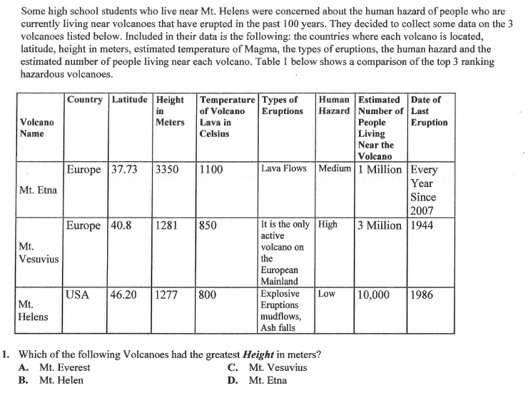4. Underline the important words in the question.
5. Circle where this leads you on the graph
6. What is the correct answer to question 1?

7. How did you know?

