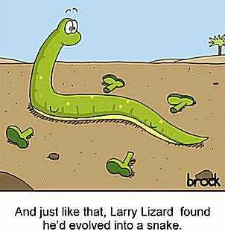
Name__________________________________________Date_______Hour_____

Evidence for Evolution: What makes it a scientific theory?

What is a scientific theory?

The theory of evolution is regarded as a good scientific theory. But why should you believe it? You are going to study the pieces of evidence for evolution and then you are going to fill in the chart. Become experts!

Using the page numbers indicated in the table below, read about the different pieces of evidence and fill in the table. Then, discuss the information with a teacher in the room or another classmate. You both must be finished before you discuss it, if information does not match up, recheck book or ask for help. This is due at the end of the hour, no exceptions.

Type of Evidence | Name and Definition | Why does it support evolution? | Examples
Homologous Structures
(handout, p. 384-385)
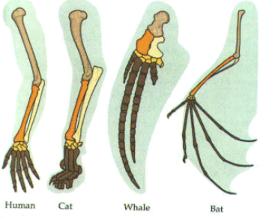

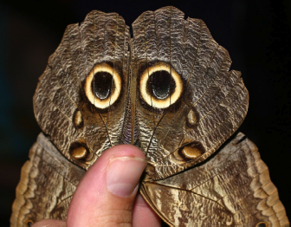
Adaptations
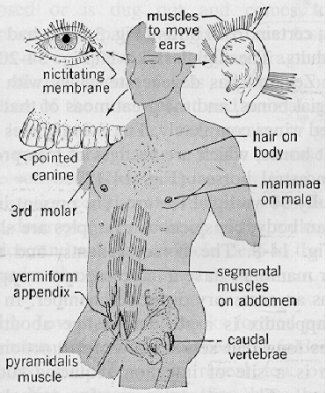
Vestigial Structures
Type of Evidence | Definition | Why does it support evolution? | Examples
Embryology
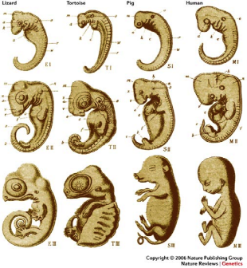

Fossils
(handout, p. 382, 417-419)

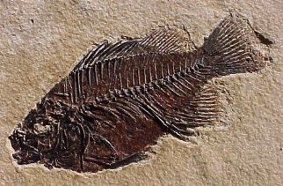

DNA/Biochemistry
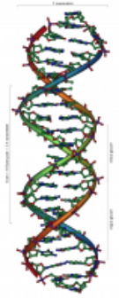

Poster Requirements:
- What is your evidence theory
- Explain and draw two examples
- How does your theory SUPPORT evolution?
- One interesting thing you learned that is not already on your poser

Your poster will be graded on:
- Displaying the information listed under poster requirements
- Neat and tidy poster
- Text is easy to read, large, and organized
- Colorful

Your Presentation will be graded on:
- Does it include all of the information on the poster?
- Is the information explained in a way that other students can understand it?
- Did the presenters answer the questions of their fellow students?

