Name:_______________________________________ Date:______________ Hour:_______
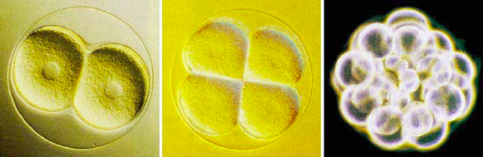
Mitosis:________________________________________________________________________________________________________

- Going from egg to baby, the fertilized egg has to:______________________________________
- Why do cells divide?
  - One Celled Organisms:
1.:______________________________________________________________________________
Examples:

  - Multicelled Organisms:
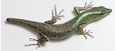
2.:_______________________________________________________________________________
Examples:

3.:________________________________________________________________________________
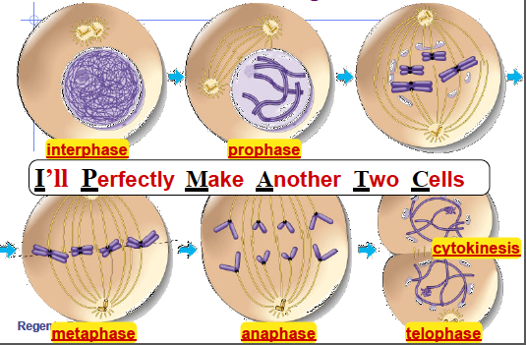
Examples:
Summary: Why do Cells Divide?

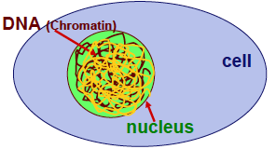
- How do cells divide? (the stages of mitosis- cell division)
  - ______________________________________
  - Cell ______________________________________________________________
  - Cell ____________________________________________________________________________________________________
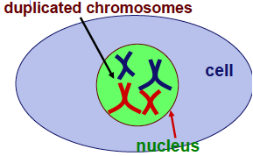
  - ________________________________________________
  - DNA winds into ______________________________________________________________________
  - This keeps the DNA ____________________________________________________________________________
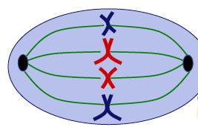
  - ________________________________________________
  - Chromosomes line up ______________________________________________
  - Attach to ______________________________________________________________________________________
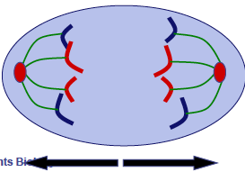
  - ________________________________________________
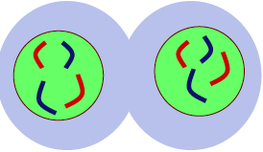
  - Chromosomes _______________________________________________ and move to _______________________________.
  - ________________________________________________
  - Cell starts to ____________________________________________
  - ____________________________________ form
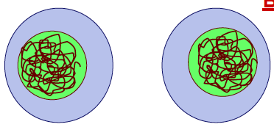
  - ________________________________________________
  - ___________________________ Divides
- The Results of Mitosis:
  - ____________________ New Daughter Cells
  - ____________________ Copies of the original cell
Summary: Explain each step of mitosis in your own words:

- What can go wrong?
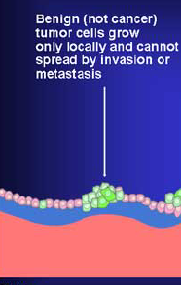
  - Cancer:_________________________________________________________________________________________________________________________________________________________________________________________________________
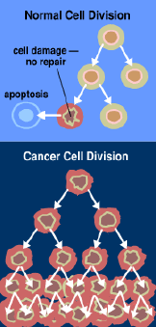
    - Types of Tumors:
      - Benign-
      - Malignant
    - Cancer can be prevented by:
      - ____________________________________________________________________
      - ____________________________________________________________________
      - ____________________________________________________________________
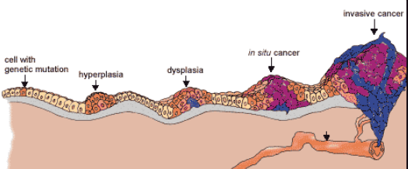
      - ____________________________________________________________________

Summary- What causes cancer?

