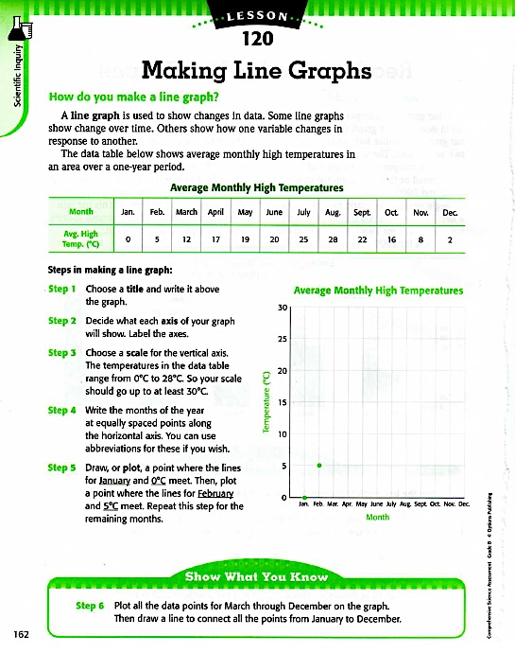

Name:________________________________________

Date:______________________________

Hour:____________________

**Explain how the curve of this line graph makes extrapolation different than when you have a straight line to use for extrapolation: **

**Extrapolate:** Predict the temperature for January of the next year. Explain your answer.

Plot the points on the graph from the table above. Connect the dots to create a line graph.

Identify the Dependent Variable:

Identify the Independent Variable: