Name:_____________________________ Date:___________ Hour:_______
Vocabulary Review for Unit One
Purpose of the assignment: The purpose of this assignment is to clearly define vocabulary words to prepare for tomorrow’s exam. Use the 1st box as the example of how to complete the vocabulary definitions.
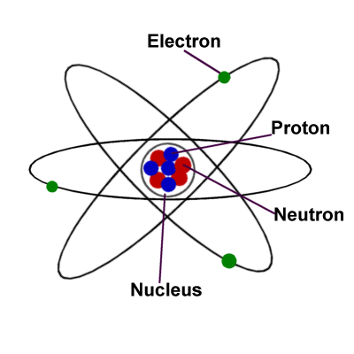
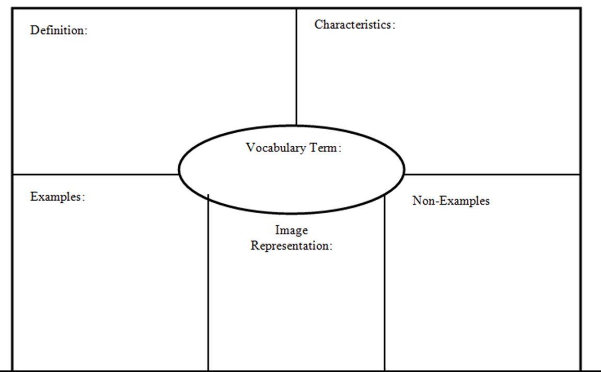
- Moods
- Thoughts
- Emotions
- Vacuum of space
- Sound
- Air
- Water
- Humans
- Earth
- Paper
- Made of atoms
- Takes up space (Volume)
- Can be in different states
- Molecules are always moving
Anything that has mass and has volume
LIQUIDLID
GAS
SOLID
MATTER
PHASE CHANGE
KINETIC ENERGY
DEPOSITION
SUBLIMATION

