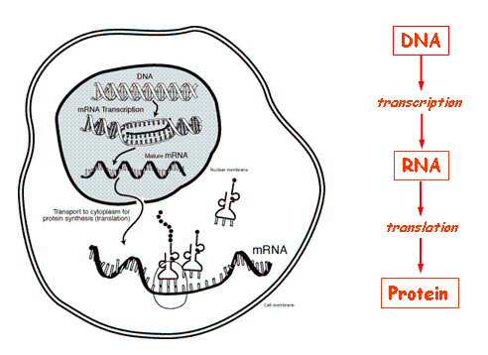
Name____________________________________________________________
PROTEIN SYNTHESIS NOTES

- What is protein synthesis?
- Using ___________________ to make a protein from the __________________ instructions
- The monomers of protein are ___________________
_____________________________

- DNA and RNA are ________________________________________. What’s the difference between DNA and RNA
DNA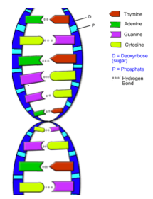 | RNA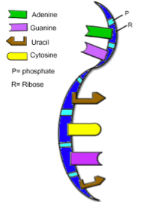
1. | 1.
2. | 2.
3. | 3.
4. | 4.

- Why are making proteins important?
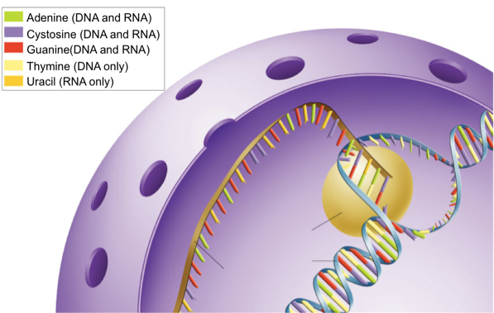
- Proteins help with: 1. Movement - _________________________
2. Regulation - _________________________
3. Structure - __________________________
4. Transport - __________________________
5. Defense - ____________________________

- How does protein synthesis work?
- TRANSCRIPTION
- Occurs in the ____________________________________
- ______________________________________________________________________________________________________________________________________________________
- Using the DNA stand as a template, make the matching mRNA copy of information.
DNA: T-A-C-A-C-T-C-C-G-T-A-G-C-A-T-T
mRNA : __________________________________

- RNA SPLICING/RNA PROCESSING
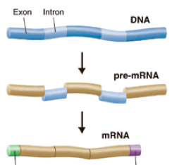
1. Occurs in the ________________________________
2. _________________________________________________
_________________________________________________
_________________________________________________
_________________________________________________
3. Using the pre-mRNA strand, remove the underlined part
pre-mRNA: A-U-G-U-G-A-G-G-C-A-U-C-G-U-A-A
mRNA: ___________________________________

Intron= ___________________________________________________________
Exon= _____________________________________________

- TRANSLATION
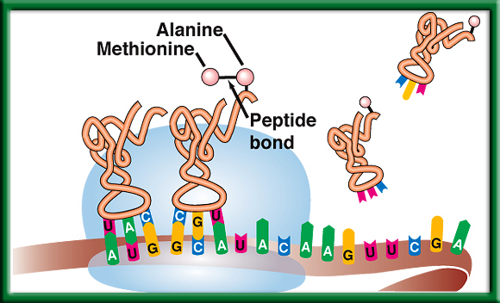
1. Occurs on a ___________________________________________
2. ________________________________________________
________________________________________________
________________________________________________
_________________________________________________

- Draw a line after every three letters in the mRNA code below. These three letters are
called a _________________________________.
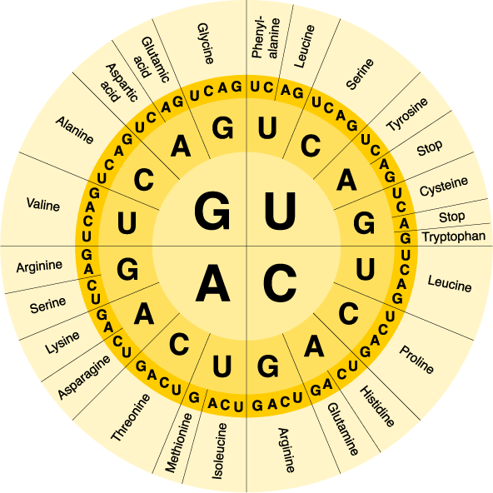
- Use the chart to translate the codons into amino acids,
mRNA: A-U-G-G-C-A-U-C-G-U-A-A
amino acids: ___________________________________
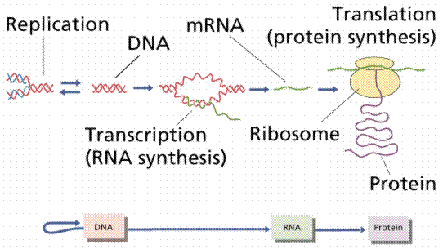

- What if there are problems?
- What is a mutation? ________________________________________________________________
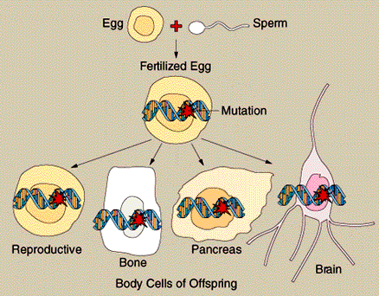
1. Mutations in Reproductive Cells
- in gametes (___________________________________)
- ______________________________ be passed on to offspring
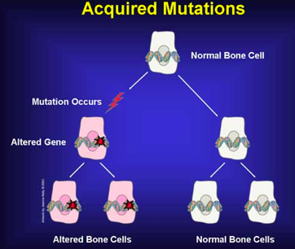
2. Mutations in Body Cells
a. normal cells (___________________)
b. _____________________________ be
passed on to offspring

- Types of Mutations
________________mutations & __________________________ mutations

- Types of ______________________Mutations
1. __________________________ mutation-a change in a single base pair in the DNA.
- May or may not interfere with _____________________________ production.
- i.e. ______________________________________________________
THE DOG BIT THE CAT
THE DOG BIT THE CAR
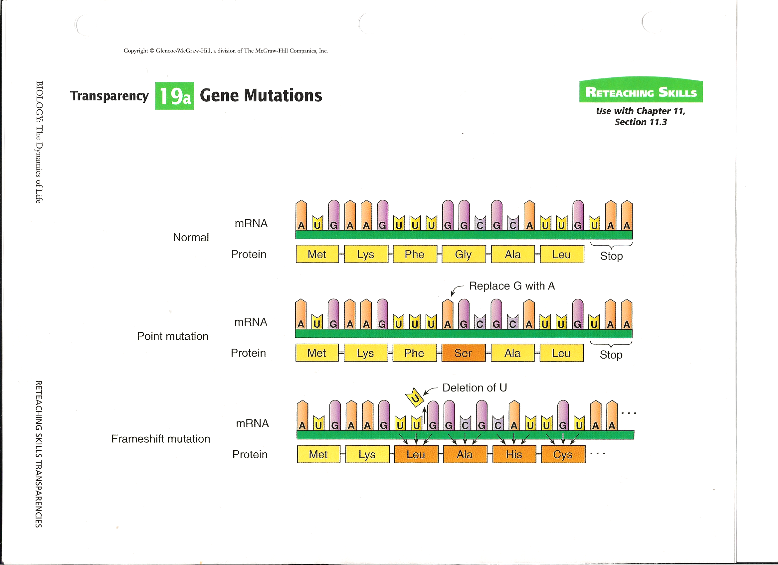

- _____________________________ mutation-where a single base pair is added or deleted, causing a shift in how the strand will be read.
- Many _________________can be affected and will not function properly.
THE DOG BIT THE CAT
THE DOB ITT HEC AT

- Types of ___________________________Mutations
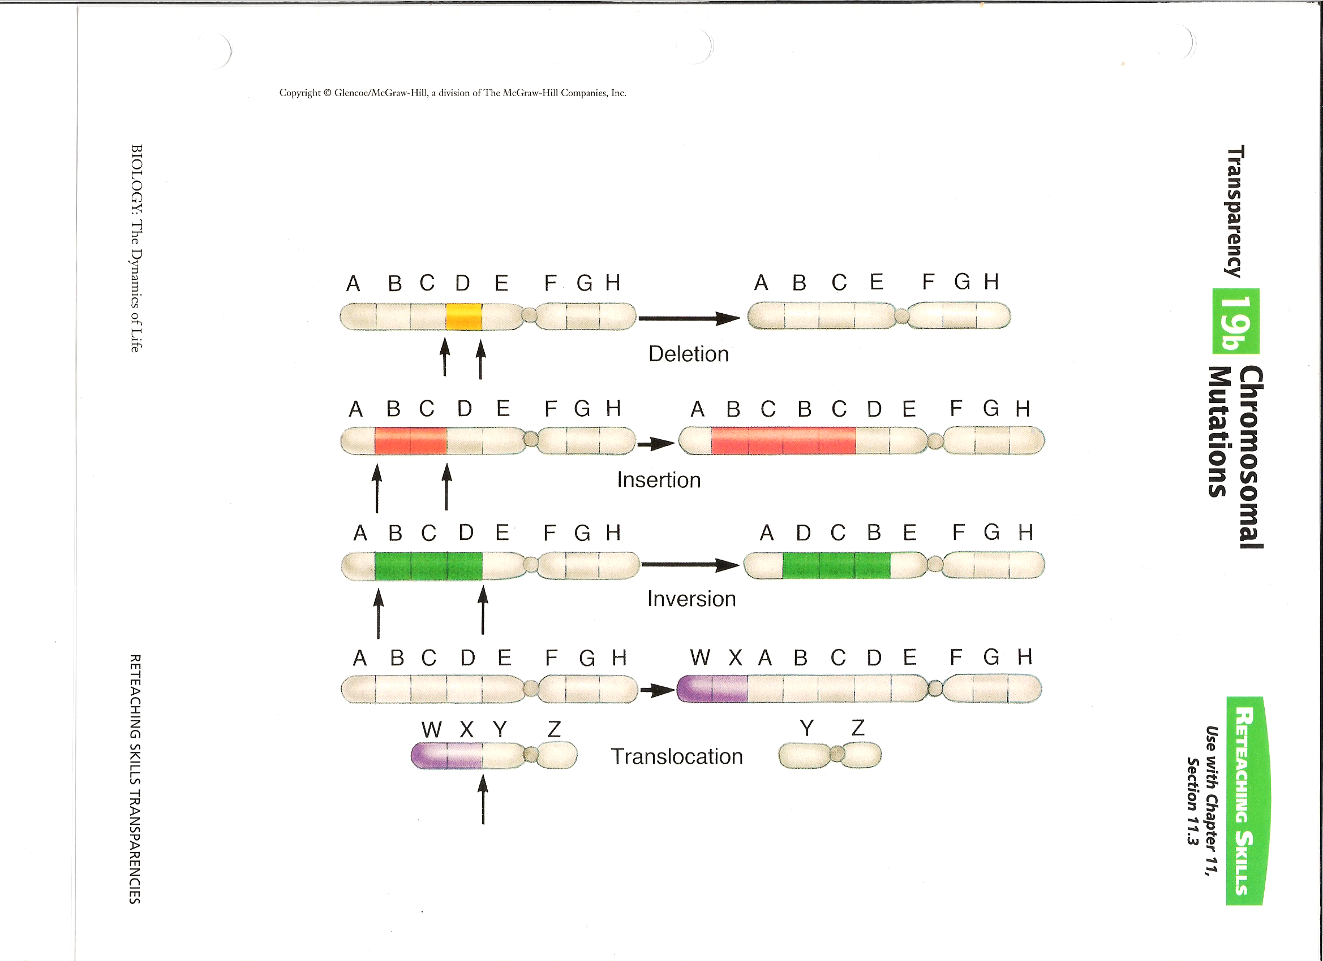
- ___________________________-part of a chromosome is left out.

- ___________________________-part of a chromatid breaks off & attaches to its sister chromatid.

- ___________________________--part of a chromosome breaks off & reinserts backwards.

- ___________________________-part of one chromosome breaks off & is switched with a piece from a different non-sister chromosome.

- What causes mutations?
- ____________________________________________________________
- ______________________________________
- any agent that can cause a change in DNA is called a ___________________________-. (x-rays, UV light, asbestos)

- DNA Repair
- ___________________________in our cells remove the incorrect nucleotides & replace them with the right ones.
- This works well, but is not perfect

- Conclusion: What do mutations ultimately cause?
- Since DNA is the instructions for making proteins…
- and mutations are mistakes in the DNA code…
- the mutations cause _____________________________________________________________.

